

**VENDOR PACKET**

**For the**

**2019 VAPT Conference**

**Richmond Marriott**

**and**

**Richmond Convention Center**

**June 16 – 20, 2019**

 **President: Cheryl Fisher Vice President: Donna Cater Secretary: Heather Handschin Treasurer: Floyd Miles Executive Director: June Eanes Director of Support Services (VDOE): Vijay Ramnarain http://www.vapt.org**

February 19, 2019

TO: Certain Vendors and Manufacturers

FROM: Fred S. Valentine, Chairman, Conference Vendor Displays

The 2019 Virginia Association for Pupil Transportation (VAPT) and the Virginia Department of Education (VDOE) Conference will be held:

**Sunday, June 18 – Thursday, June 20, 2019**

**Richmond Marriott and Richmond Convention Center**

**Downtown Richmond**

The trade show will be on **Tuesday, June 18**, from 8 a.m. to 12 noon at the Richmond Convention Center. *This conference would not be successful without you and your support! We hope you will take part in this great event.*

Information on the Trade Show is included in this packet. If you have questions, please call Fred Valentine at (804) 399-0998 or Gail Putze at (804) 365-6530.

**Board of Directors**

Phillip Griffin John Grubbs Valerie Seaborne Josh Davis

Smyth County Frederick County Greensville County Henrico County

Jeremy Gauthier-Martin Larry Frazier Kenyon Scott Darrin Wills

Harrisonburg City Town of West Point Pittsylvania County Hampton City



**WHAT** – Vendor Trade Show

**WHERE –** Richmond Convention Center

**Monday, June 17, 2019**

**Setup** - 11:00 a.m. – 5:00 p.m.

**Tuesday, June 18, 2019**

**Time of Trade Show** – 8 a.m. – 12:00 noon

**Teardown** – 1:00 p.m. – 2:30 p.m.

Registration for Vendors will be held at the

Convention Center

in front of the Exhibit Hall.

Booths – 10’ x 10’ with pipe and drape

Includes a table (6’ x 4’), 2 chairs, and wastebasket

If carpet is needed (see attachment, page 7). Please contact Exhibits, Inc. at

(804) 768-4400.

Coordinator – Fred S. Valentine

(804) 399-0998

P. O. Box 28154, Richmond, VA 23228

**Richmond Marriott Hotel Information**

[](https://www.google.com/url?sa=i&rct=j&q=&esrc=s&source=images&cd=&cad=rja&uact=8&ved=0ahUKEwjLmbvb_6nXAhUK4WMKHeIGDcwQjRwIBw&url=http://www.clipartlord.com/category/structures-clip-art/buildings-clip-art/hotel-clip-art/&psig=AOvVaw1IrWQBGfoR8nqaLLZkPzx6&ust=1510059383590527) **HOTEL Information**

**Making Reservations**: Richmond Downtown Marriott

<https://book.passkey.com/e/49771143>

If have trouble with the web link, call (804) 343-6921

Be able to provide the following information:

Credit Card number, type of card, Exp date,

Name, email, arrival and departure date

Cut-off date – Monday, May 27, 2019

**Room Rates**: Single/Double Occupancy $147

Plus, state and local taxes

**Check-In & Check-Out**: Check-in Any time after 4 p.m.

Check-out 12 p.m.

**Parking**: $6 per day at the Parking Deck behind the Marriott (Additional information will be coming out on how this will be handled)

**Vendor Parking**

There is parking available behind the Convention Center at the loading dock for a cost or you may park in the parking deck at the corner of 3rd and Marshall at $7 per day.

**Information on Trade Show**

**Internet Connection –** Wi-Fi will be provided.

**Electrical** – Will be provided for those vendors requesting it. Please indicate if you need electrical on the registration form.

**Shipping of Materials to the Convention Center –** The earliest a shipment can arrive is Friday, June 14. Use the following address for shipments: Greater Richmond Convention Center, VAPT Conference, (Name of Vendor), 403 North 3rd Street, Richmond, VA 23219

**Shipping of Materials from the Convention Center** – Box materials, wrapped, and label fixed on the package. You will need to call the carrier (FedEx, UPS, etc.) to schedule a pickup. At the end of the show, you will be instructed on where to drop these packages so they can be taken to the pickup area.

**Hold Harmless Clause** – Please complete the enclosed form and return it with your registration.

**Break-down after the show** – Immediately following the end of the Trade Show.

**Questions:** Contact Fred Valentine at (804) 339-0998 or Gail Putze at (804) 365-6530.

**Prizes for Attendees:** Attendees will have a copy of their name badge that they will drop in a box when they enter the trade show. VAPT will hold drawings every 30 minutes beginning at 8 am. **The attendee’s name drawn must be present to win**. If you would like to donate a prize for this drawing, please contact Fred Valentine or Gail Putze. Thank you for your participation in our trade show. The success of our conference depends on our vendors.

**Unloading at Convention Center –** Refer to the enclosed diagram on page 8. The Trade Show will be held in Exhibit Hall B.

**Virginia Association for Pupil Transportation**



TO: Certain Vendors and Manufacturers

FROM: Fred S. Valentine, Chairman, VAPT Conference Trade Show

P. O. Box 28154

Richmond, VA 23228

Phone: (804) 399-0998

FAX: (804) 264-8138

E-Mail: [FtDusters@aol.com](mailto:FtDusters@aol.com)

The Richmond Convention Center requires the Virginia Association for Pupil Transportation, its Exhibitors and

Contractors to provide a “Hold Harmless” statement prior to the use of their facilities.

**“HOLD HARMLESS CLAUSE”**

The exhibitor assumes the entire responsibility and liability for losses, damages, and claims

arriving out of injury or damage to exhibitor’s displays, equipment and other property brought

upon the premises of the Hotel and shall indemnify and hold harmless the Richmond Convention Center and

the Virginia Association for Pupil Transportation from any and all such losses, damages and claims.

______________________ __________________________________

Date Signature

__________________________________

Company Name

Please sign, date, and return one copy of this statement to:

Gail Patterson Putze

Hanover County Public Schools

11375 North Lakeridge Parkway

Ashland, VA 23005

Phone: (804) 365-6530

FAX: (804) 365-6529

E-Mail: [gpatterson@hcps.us](mailto:gpatterson@hcps.us)

Keep a copy of this form for your files.

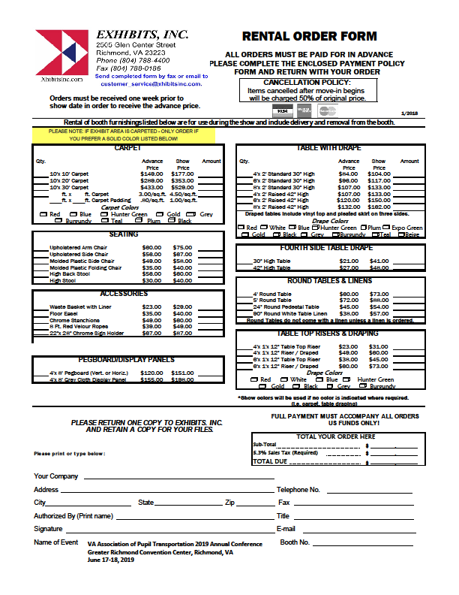

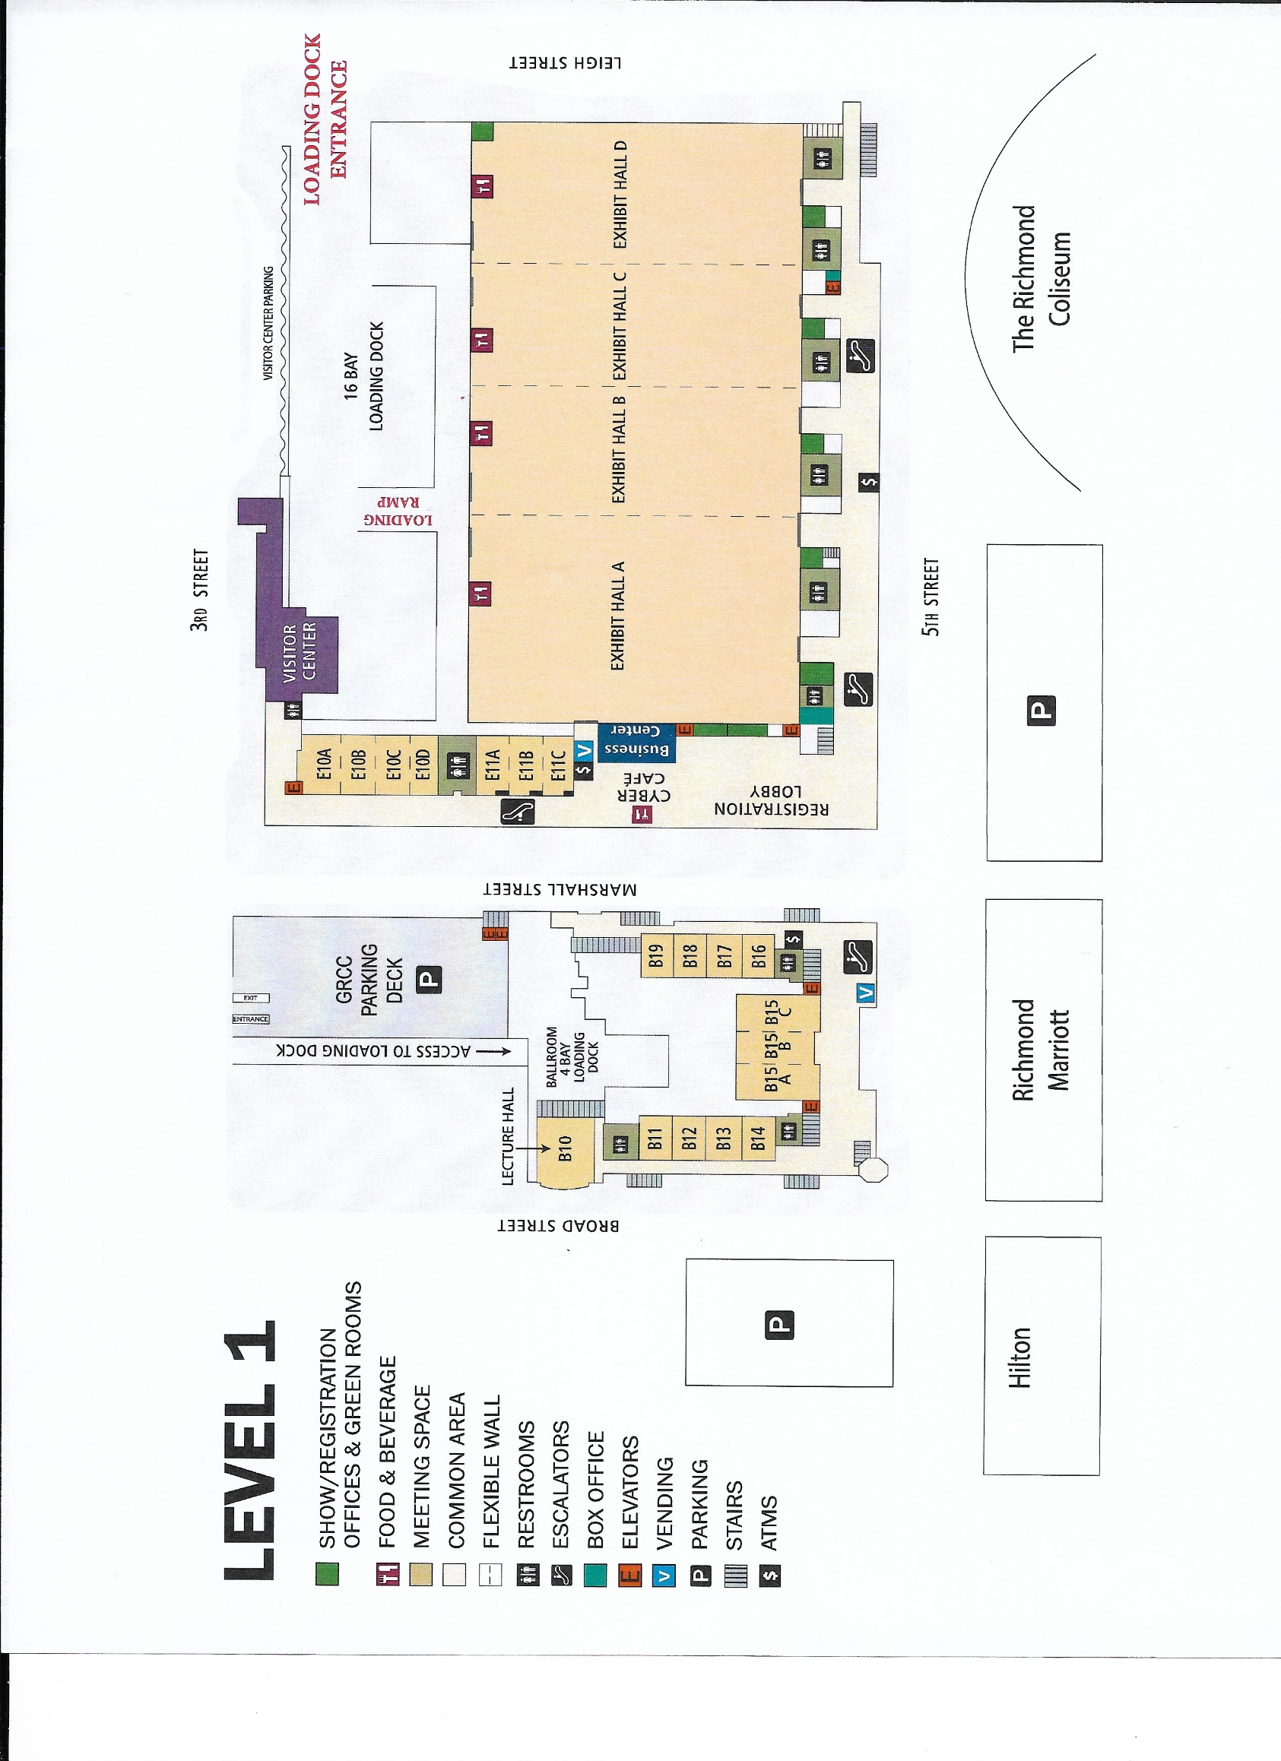



**Information on Conference Activities**

**Sponsorship of events**

Many of the VAPT/DOE functions are sponsored by the vendors. If your company would like to have an opportunity to sponsor an event, or give a donation toward an event, please complete the line on the **Tradeshow Display Space form, line G.**

**Clyde W. Morris Memorial Scholarship**

On March 29, 1994, Clyde W. Morris, who was supervisor of pupil transportation for the Louisa County Public Schools, made the ultimate sacrifice in the performance of his duties to ensure that the safety of all students riding school buses to and from Louisa County Public Schools was not compromised. During the early morning hours following severe storms and heavy rains, Mr. Morris was checking the conditions of the county’s roadways to determine if school buses could traverse the roads safely with students on board. Mr. Morris became trapped and drowned in his attempt to escape rising flood waters.

In recognition of his extreme dedication to the ideals of student safety, the Virginia Association for Pupil Transportation (VAPT) established the Clyde W. Morris Memorial Scholarship in 1995-96 as a tribute to all pupil transportation personnel in the Commonwealth of Virginia, whose ultimate goal is to provide safe transportation for all children. In June of each year, a scholarship is awarded to a Virginia public school senior who is a child or grandchild of any public school pupil transportation employee in the Commonwealth and who is continuing their education beyond the secondary level. The scholarship may be used to cover education expenses at a postsecondary educational institution in support of a student’s tuition, books or fees.

If your organization is interested in making a donation to the VAPT scholarship fund, please include this on the **Tradeshow Display Space Form, line H.**

**Door Prizes**

If you are interested in sharing a small gift for a door prize, please give it to Gail Putze or Fred Valentine when checking in at the Trade Show.

**Membership Application**

The membership application is located on the VAPT website <http://www.vapt.org/Membership.htm>.

**We thank you for your continued support of the Virginia Association for Pupil Transportation!**

**REQUEST FOR TRADESHOW DISPLAY SPACE**

**Virginia Association for Pupil Transportation**

**Tuesday, June 18, 2019 (8 a.m. to 12 noon)**

**Please Complete the following:**

FIRM NAME (How to list in program)____________________________________________________ Product Line:_____________________________

Mailing Address: ___________________________________________________________________ Telephone: ______________________________

Fax: _________________________ E-Mail: ____________________________________________ Contact: _________________________________

Website: ___________________________________________________________________________________________________________________

1. Booth Spaces _______ x $425 = $__________ Representatives Names (2 representatives included in display cost)

(PUT ADDITIONAL REPRESENTATIVES ON BACK OF FORM)

1. Bus Spaces (Up to 3 per vendor) ______ x $450 = $__________ __________________________________________________
2. Banquet Tickets _______ x $ 40 = $__________ __________________________________________________
3. VAPT Memberships _______ X $ 25 = $__________ __________________________________________________
4. Golf Tournament _______ x $ 40 = $__________ __________________________________________________
5. Additional Representatives _______ x $ 25 = $ __________ __________________________________________________
6. Sponsorship of an event or a donation

toward an event $__________ Wi-Fi and Electrical included.

1. Donation to Scholarship $ __________
2. **Total Amount Enclosed: $__________ PLEASE INDICATE IF YOU REQUIRE ELECTRICAL. ________**
3. **Checks should be made payable to VAPT.** **Refunds will not be given**.
4. If paying membership dues, please complete the Membership Application (<http://www.vapt.com>) and submit to the person indicated on the form.
5. Return this form and check to: Gail Putze, c/o Hanover County Public Schools, 11375 Lakeridge Parkway, Ashland, VA 23005

Phone number: (804) 365-6530; Fax: (804) 365-6529

1. Questions: Fred S. Valentine – E-Mail [ftdusters@aol.com](mailto:ftdusters@aol.com); Phone number: (804) 399-0998

****[](https://www.bing.com/images/search?q=clipart+of+golf&id=0D8504EB55E86E50215B9E056863778F41672985&FORM=IQFRBA)**2019 Bryan W. Morris, Sr.**

**Memorial Golf Tournament**

# Virginia Association For Pupil Transportation

# WHO - - - All Pupil Transportation Golfers

# (Administrators, Drivers, Technicians, Vendors, Secretaries, Suppliers, etc.)

**WHEN ---** Monday,June 17, 2019 8 AM Shot Gun

**WHERE --- Birkdale Golf Club**

8511 Royal Birkdale Drive

Chesterfield, VA 23832

**Cost --- $40 ($35 for golf, $5 for prizes)**

**REGISTRATION DEADLINE ---** June 5, 2019

**COORDINATOR --- David Pace, Virginia Beach Public Schools**

**PRIZES: First, Second, Third place teams**

**Trophies provided by GCR Tire and Service: First, second, third place teams**

**Lunch provided by Kingmor Supply, Inc.**

---------------------------------------------------------------------------------------------------------------------------------------------------

Please provide the following information if you wish to play in the golf tournament.

Make check for $_______ (per player) payable to VAPT.

_______ Please check if payment is included with Request for Tradeshow Display Space, Line E.

Send payment to: David Pace, 2669 Hartley Street, Virginia Beach, VA 23456

**-----------------------------------------------------------------------------------------------------------------------------------------------------------------**

NAME(s): __________________________________________________________________________________________

ADDRESS: __________________________________________________________________________________________

___________________________________________________________________________________________________

___________________________________________________________________________________________________

PHONE: ____________________________________________________________________________________________

SCHOOL SYSTEM/OR VENDOR: __________________________________________________________________________

HANDICAP(s): _______________________________________________________________________________________

***NOTE: IF YOU ARE ENTERING A TEAM, please list all players on the form.***



**2019**

**ANNUAL**

**VAPT AND VDOE**

**Professional Development**

**CONFERENCE**

**Marriott Hotel/Richmond Convention Center**

**Richmond, VA**

**June 16 – 20, 2019**



**Sunday, June 16, 2019**

5 – 7 pm **Registration**

*Location*:

*Coordinator*: June Eanes, Executive Director, VAPT

6 – 8 pm **Reception**

*Location:*

Sponsored by Blue Bird Sales of VA

8 – 9 pm **New Directors’ Conference Orientation**

*Location*:

**Monday, June 17, 2019**

8 am **Bryan W. Morris, Sr. Memorial Golf Tournament**

*Location*: Birkdale Golf Club

8511 Royal Birkdale Drive

Chesterfield, VA 23832

*SHOT GUN*: 8 am

*Coordinator*: David Pace, Virginia Beach City

8 am **School Bus Road-e-o**

Shuttles will leave hotel at

*Location*: Arthur Ashe Center (at the Diamond)

*Coordinator*: Jeremy Gauthier-Martin, Harrisonburg City

**Lunch** sponsored by Blue Bird Sales of VA

8 am **Technician’s Competition**

Shuttles will leave hotel at

*Location:* Sonny Merryman, Inc.

11228 Hopson Road

Ashland, VA 23005

*Coordinator*: Robert Clinebell, Norfolk City

8 am **NAPT Course 202 Presentation Skills**

*Location*:

*Instructor*:

8 am **NAPT Course 304 Data Driven Decision Making**

*Location*

*Instructo*r:

10 – 5 pm **Registration**

*Location*:

*Coordinator*: June Eanes

**Shirt Sales**

*Location:*

*Coordinators*: Edward Tucker, Dinwiddie County, Darrin Wills, Hampton City

11 am – 5 pm **Exhibitors Setup**

*Location*: Richmond Convention Center, Hall B

*Coordinators*: Fred Valentine, Retired

Gail Putze, Hanover County

3:00 pm **First General Session**

*Location*:

Marriott Hotel

Presentation of Colors

Pledge of Allegiance

National Anthem

Invocation

Welcome – Mr. Jason Kamras, Superintendent,

Richmond City Schools

**VAPT Business Meeting**

**Keynote:**

*Speaker:* Mr. Paul Mellor, Success Links

5 pm **Vendor Hospitality Night or Dinner on your own**

**Tuesday, June 18, 2019**

7:30 am **Registration**

*Location*: Marriott Hotel

*Coordinator*: June Eanes

8 am – 12 noon **Trade Show & School Bus Display**

*Location*: Richmond Convention Center, Hall B

*Coordinators*: Fred Valentine, Gail Putze

**Continental Breakfast in Exhibit Area**

Sponsored by:

12 noon **Lunch in the Trade Show Area** (Must have a coupon to receive a lunch)

1 pm – 4 pm **Technician’s Sessions**

Shuttles will leave hotel at

*Location:* Martin Luther King Jr. Middle School

1000 Mosby Street

Richmond, VA

*Coordinator:* Bob Clinebell

1:00–4:30 pm **Second General Session**

*Location*: Marriott Hotel

5:30 pm **Family Night Dinner**

**Sponsored** by Sonny Merryman, Inc.

Buses leave hotel at

**Wednesday, June 19, 2019**

8 am – 4 pm **Technician’s Sessions**

Shuttles will leave hotel at

*Location*: Martin Luther King Jr. Middle School

1000 Mosby Street

Richmond, VA

*Coordinator*: Bob Clinebell

7:30 am **Continental Breakfast**

*Location:* Marriott Hotel

*Sponsors*:

8 am - noon **Breakout Sessions**

*Location*:

8 – 10:30 am ____________________________

*Speaker*:

*Moderator*:

*Location*:

8 – 9:45 am ___________________________

*Speaker*:

*Moderator*:

*Location*:

8 – 9:45 am ___________________________

*Speaker*:

*Moderator*:

*Location*:

8 – 9:45 am **______________________________________**

*Speaker*:

*Moderator*:

*Location*:

10 – 11:45 am **____________________________**

*Speaker*:

*Location*:

10 – 11:45 am **____________________________________**

*Speaker*:

*Location*:

11:45–1:30 pm **Lunch on your own**

1:30-4:00 pm **__________________________________________**

*Speaker*:

*Location*:

1:30–3:45 pm **Round Table Discussions**

*Leaders*:

*Location*:

5 – 6 pm **Reception**

*Location*:

**Sponsored** by Kingmor Supply, Inc.

6 pm **Banquet**

*Location*:

Presiding: Cheryl Fisher, President

Poster Contest: Diane Stewart, Virginia Beach

Golf: David Pace, Virginia Beach

Road-e-o: Jeremy Gauthier-Martin

Scholarships: Linwood Horne, Hanover Co.

Dean Farmer, Sonny Merryman, Inc.

Technicians: Bob Clinebell, Norfolk City

Hall of Fame: Barry Sudduth, Stafford Co.

**Dance** (30 minutes following the end of the Banquet)

*Location*:

**Sponsored** by Kingmor Supply

**Thursday, June 21, 2019**

9 – 12 noon Closing Session

8 – 9 am **Breakfast**

*Location:*

**Sponsored** by Kingmor Supply, Inc.

8:30 – 9 am

9 – 10 am **Lessons Learned**

10 – 11 am **VAPT Business Meeting**

11 am **Announcements**

**VAPT EXECUTIVE BOARD**

President – Cheryl Fisher, Fauquier County

Vice President – Donna Carter, Franklin County

Secretary – Heather Handschin, Prince William County

Treasurer – Floyd Miles, Richmond City

Past President – James Lash, York County

Executive Director – June Eanes, Retired

**Board of Directors**

Region 1 – Josh Davis, Henrico County

Region 2 – Darrin Wills, Hampton City

Region 3 – Larry Frazier, Town of West Point

Region 4 – John Grubbs, Frederick County

Region 5 – Jeremy Gauthier-Martin, Harrisonburg City

Region 6 – Kenyon Scott, Pittsylvania County

Region 7 – Phillip Griffin, Smyth County

Region 8 – Valerie Seaborne, Greensville County

**DOE Staff**

Vijay Ramnarain, Director of Support Services

Alice Matthews, Administrative Assistant

Kerry Miller, Associate Director

Jackie Herring, Associate Specialist

Crystal Blowe, Associate Specialist

Dr. James F. Lane, Superintendent of Public Instruction

Kent C. Dickey, Deputy Superintendent for Finance and Operations